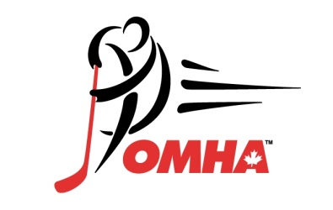

Dresden Minor Hockey Association

presents the

DRESDEN KINSMEN CUP

U9, U11, U13, U15 & U18 TOURNAMENT

FEBRUARY 3rd, 2023 – FEBRUARY 5th, 2023

Open to House League and Local League Teams only (No Select Teams)

Entry Fee: $925 All Divisions

Please make cheques payable to Dresden Minor Hockey Association or etransfer to KinsmenCup@DresdenMinorHockey.com

3 GAME GUARANTEE
GREAT COMPETITION

Three venues will be used to host this tournament: Ken Houston Arena – Dresden, Ridgetown Arena - Ridgetown & Bothwell Arena - Bothwell

Games will begin at 9am on Friday

Contact: Mike Bosma
25178 St. Clair Rd
Dover Centre, ON N0P 1L0
Email: KinsmenCup@DresdenMinorHockey.com
Tel: (519) 380- 5914 (cell)

Website: http://www.DresdenMinorHockey.com/

Remember to Register Early*
*Entry fee & registration forms must be received to secure your space in the tournament.

Dresden Minor Hockey Association

presents the

DRESDEN KINSMEN CUP

U9, U11, U13, U15, U18 TOURNAMENT

APPLICATION
Team Name: ____________________
Minor Hockey Association: _____________________
Division: ☐U9 ☐U11 ☐U13 ☐U15 ☐U18
Jersey Colours: Home: __________(light) Away: __________ (dark)
Contact: Name: ___________________________
Address: _________________________
City / Province: ____________________
Postal Code: ______________________
Phone: ___________________________
Email: ____________________________________

By signing this entry form, the team official, on behalf of his/her team, releases the sponsors of the above tournament, it’s officials, arena management, Dresden Minor Hockey Association and all concerned with the tournament from liability for any injury or accident which may be incurred by any player or team official while participating in the tournament or while traveling to or from the tournament.

Team Official Signature: _______________________

Dresden Minor Hockey Association

presents the

DRESDEN KINSMEN CUP

U9, U11, U13, U15, U18 TOURNAMENT

TEAM ROSTER SHEET
 | Player Name |  | DOB | Jersey #
1
2
3
4
5
6
7
8
9
10
11
12
13
14
15
16
17
18
Team Officials (Rostered) |  | Name
Head Coach
Assistant Coach
Assistant Coach
Trainer
Assistant Trainer
Manager

